**Half Adder-**

* Half Adder is a combinational logic circuit.
* It is used for the purpose of adding two single bit numbers.
* It contains 2 inputs and 2 outputs (sum and carry).

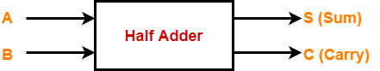

**Half Adder Designing-**

Half adder is designed in the following steps-

**Step-01:**

Identify the input and output variables-

* Input variables = A, B (either 0 or 1)
* Output variables = S, C where S = Sum and C = Carry

**Step-02:**

Draw the truth table-

|  |  |  |  |
| --- | --- | --- | --- |
| **Inputs** | | **Outputs** | |
| **A** | **B** | **C (Carry)** | **S (Sum)** |
| 0 | 0 | 0 | 0 |
| 0 | 1 | 0 | 1 |
| 1 | 0 | 0 | 1 |
| 1 | 1 | 1 | 0 |

**Truth Table**

**Step-03:**

Draw K-maps using the above truth table and determine the simplified Boolean expressions-

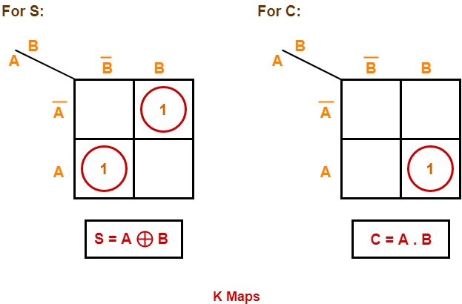

**Step-04:**

Draw the logic diagram.

The implementation of half adder using 1 XOR gate and 1 AND gate is as shown below-

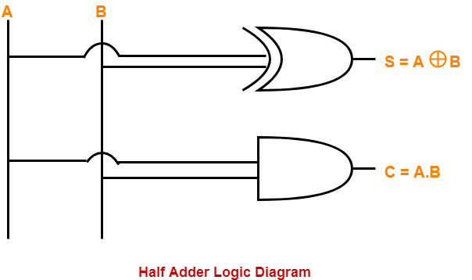

**Limitation of Half Adder-**

* Half adders have no scope of adding the carry bit resulting from the addition of previous bits.
* This is a major drawback of half adders.
* This is because real time scenarios involve adding the multiple number of bits which can not be accomplished using half adders.

To overcome this drawback, Full Adder comes into play.

**Full Adder-**

* Full Adder is a combinational logic circuit.
* It is used for the purpose of adding two single bit numbers with a carry.
* Thus, full adder has the ability to perform the addition of three bits.
* Full adder contains 3 inputs and 2 outputs (sum and carry) as shown-

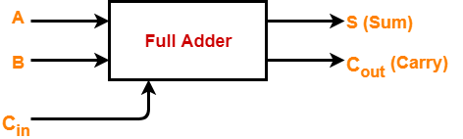

**Full Adder Designing-**

Full adder is designed in the following steps-

**Step-01:**

Identify the input and output variables-

* Input variables = A, B, Cin(either 0 or 1)
* Output variables = S, Cout where S = Sum and Cout = Carry

**Step-02:**

Draw the truth table-

|  |  |  |  |  |
| --- | --- | --- | --- | --- |
| **Inputs** | | | **Outputs** | |
| **A** | **B** | **Cin** | **Cout (Carry)** | **S (Sum)** |
| 0 | 0 | 0 | 0 | 0 |
| 0 | 0 | 1 | 0 | 1 |
| 0 | 1 | 0 | 0 | 1 |
| 0 | 1 | 1 | 1 | 0 |
| 1 | 0 | 0 | 0 | 1 |
| 1 | 0 | 1 | 1 | 0 |
| 1 | 1 | 0 | 1 | 0 |
| 1 | 1 | 1 | 1 | 1 |

**Truth Table**

**Step-03:**

Draw K-maps using the above truth table and determine the simplified Boolean expressions-

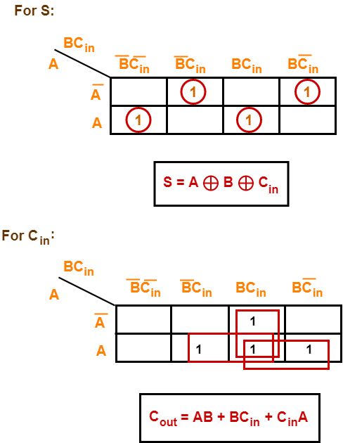

**Step-04:**

Draw the logic diagram.

The implementation of full adder using 1 XOR gate, 3 AND gates and 1 OR gate is as shown below-

